Lavori estivi

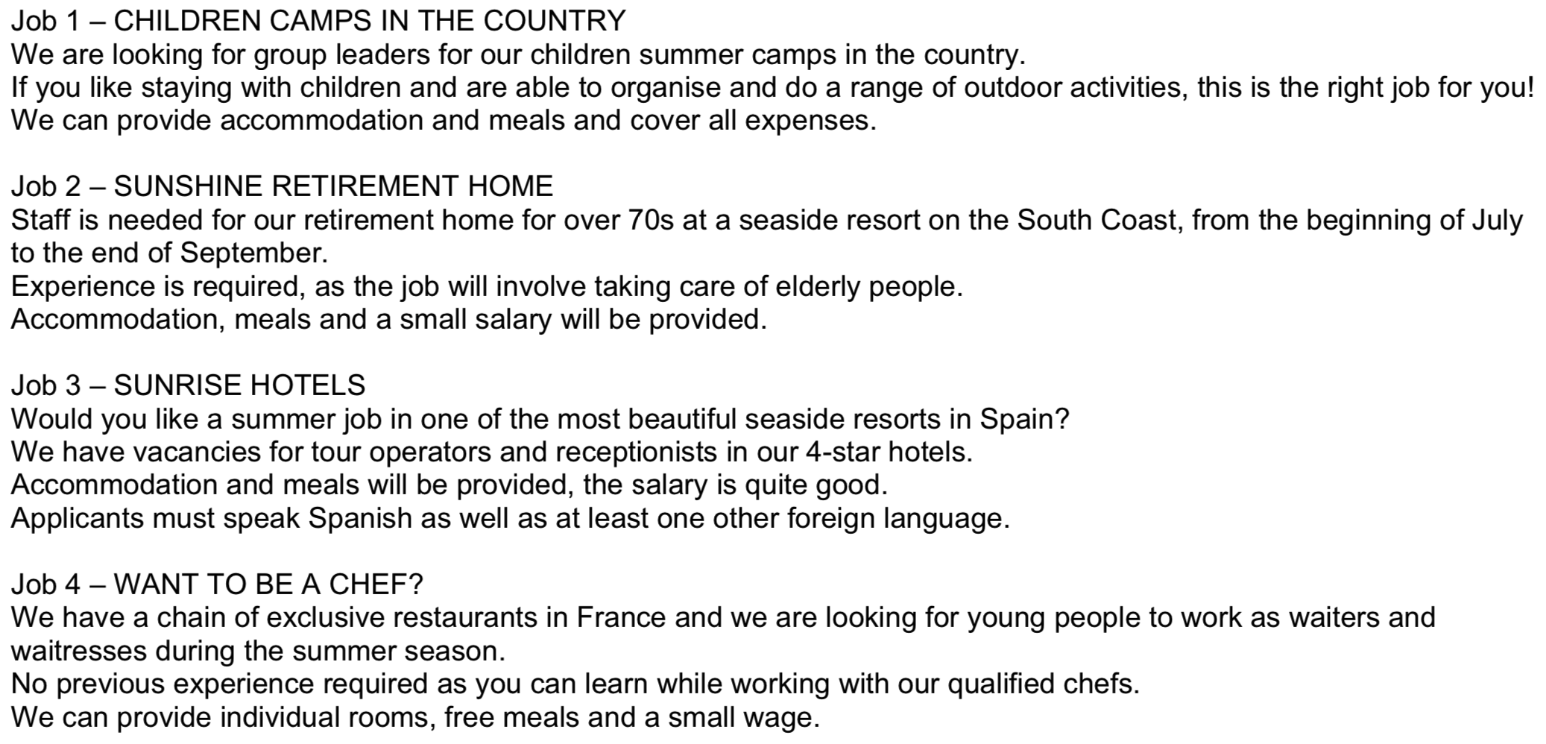

|  |
| --- |
| Italiano |
| Job 1 |
| Job 2 |
| Job 3 |
| Job 4 |

Quattro personaggi   
in cerca di un lavoro estivo

|  |  |
| --- | --- |
| Inglese | Italiano |
| **Mary** is going to study Medicine at university next year and she would like to find a summer job at the seaside. She loves helping people and has already worked with elderly people as a volunteer. She doesn’t mind working hard. |  |
| **Bob** is a student and he is looking for a holiday job to get a break from the town. He’s an active young man, he loves walking, staying outdoors and he’s very good at organising things. |  |
| **Alan** would like to open his own restaurant in the future and he’s looking for a holiday job. He’s more interested in gaining experience than in earning money. He likes travelling and can speak French, German and Spanish. |  |
| **Janet** is going to attend an expensive course next year so she would like to find a well aid job. She likes being with other people and having experiences abroad. She can speak German, French and Spanish. |  |

Parole o frasi nuove che ho imparato:

|  |  |
| --- | --- |
| Inglese | Italiano |
|  |  |
|  |  |
|  |  |
|  |  |